

Practical No. : 3
Aim : –
Implement control structures and form validation; create a grading system based on user-entered marks.
Software/Tools Required –
- VSCode,
- Chrome,
- HTML5,
- CSS3,
- Javascript (ES6)
Experiment Program Code –
index.html
<!DOCTYPE html>
<html>
<head>
<title>Student Grading System</title>
<link rel="stylesheet" href="style.css">
</head>

<body>

<form>

<img src="./sym logo.png"
alt="Logo"
style="position:absolute; top:20px; left:10px; width:100px; height:120;">
<div class="container">

<h2 class="logo">SYMBIOSIS INSTITUTE OF TECHNOLOGY</h2>

<p class="sub">Student Grade Portal</p>

<input type="text" id="name" placeholder="Student Name">

<input type="text" id="prn" placeholder="PRN Number">

<input type="number" id="marks" placeholder="Enter Marks">

<button onclick="gradeSystem()">SUBMIT</button>

<div id="result"></div>

</div>
</form>

<script>
function gradeSystem() {
var name = document.getElementById("name").value;
var marks = document.getElementById("marks").value;

if(name == "") {
alert("Please enter student name: ");
return;
}

if(marks == ""){
alert("Please enter marks: ");
return;
}
marks = Number(marks);

if(marks < 0 || marks > 100) {
alert("Marks should be between 0 and 100.");
return;
}

var grade;
var result;

if(marks >= 90) {
grade = "A+";
result = "Pass";
}
else if(marks >= 80) {
grade = "A";
result = "Pass";
}
else if(marks >= 70) {
grade = "B";
result = "Pass";
}
else if(marks >= 60) {
grade = "C";
result = "Pass";
}
else if(marks >= 50) {
grade = "D";
result = "Pass";
}
else if(marks >= 40) {
grade = "E";
result = "Pass";
} else {
grade = "F";
result = "Fail";
}
document.write("<h2>Student Grade Report</h2>");
document.write("<hr>");
document.write("<b>Student Name:</b> " + name + "<br> <br>");
document.write("<b>Marks:</b> " + marks + "<br> <br>");
document.write("<b>Grade:</b> " + grade + "<br> <br>");
document.write("<b>Result:</b> " + result);
}
</script>
</body>
</html>

Output –
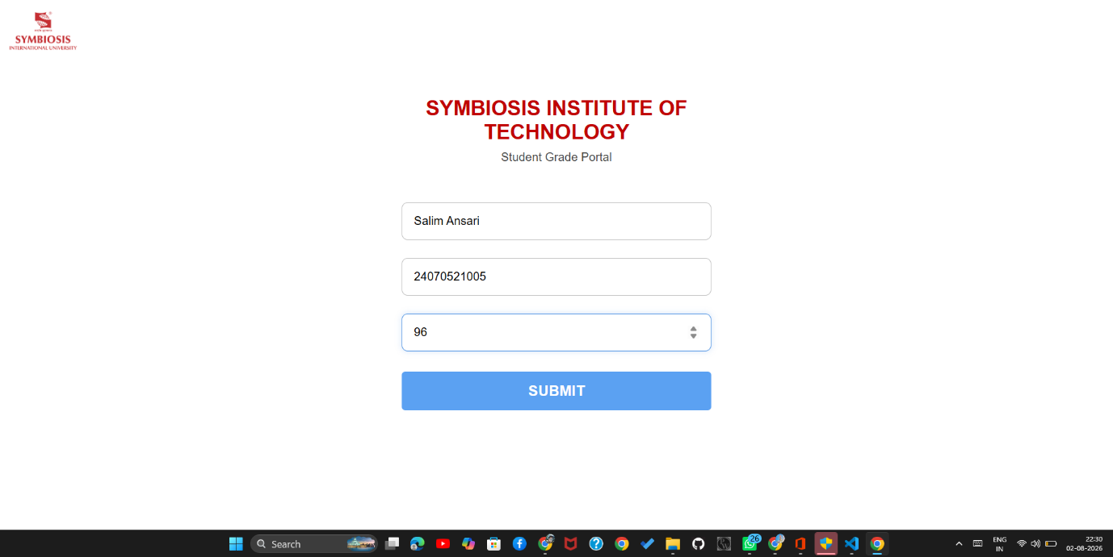
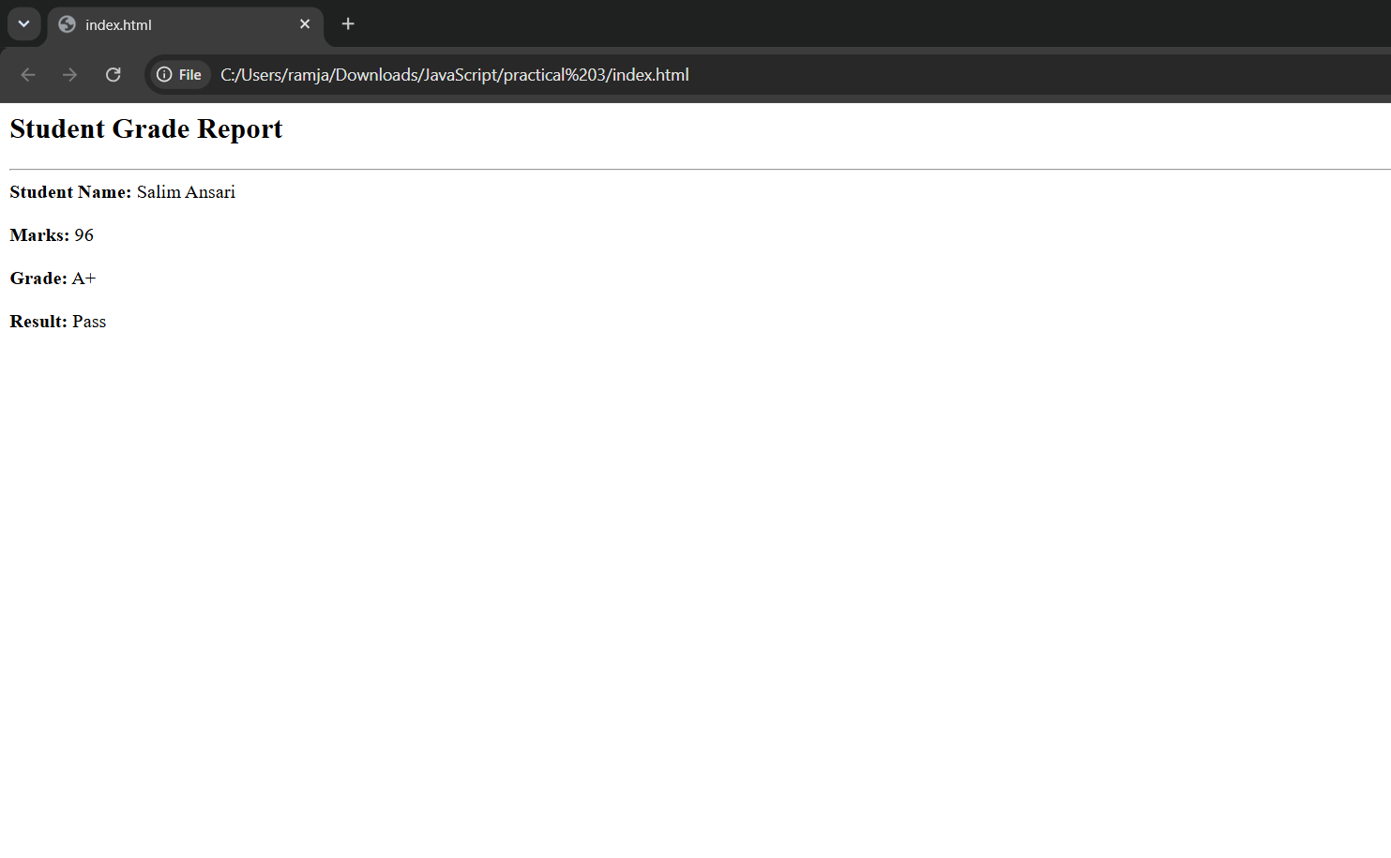
Case Study Title –
To develop a login page using HTML and JavaScript that validates user credentials using conditional statements (if, else if, and else) and displays appropriate messages based on the input.

Case Study Program Code –
index.html
<!DOCTYPE html>
<html lang="en">
<head>
<meta charset="UTF-8">
<meta name="viewport" content="width=device-width, initial-scale=1.0">
<title>Result Portal</title>
<link rel="preconnect" href="https://fonts.googleapis.com">
<link href="https://fonts.googleapis.com/css2?family=Playfair+Display:wght@600;700;800&family=Inter:wght@400;500;600;700&family=JetBrains+Mono:wght@500;600&display=swap" rel="stylesheet">
<style>
:root{
--navy: #16233f;
--navy-deep: #0d1626;
--gold: #c9a227;
--gold-soft: #e6cf8c;
--paper: #f8f3e8;
--paper-line: #e3d8bd;
--ink: #2a2620;
--ink-soft: #6b6455;
--pass: #3f7a5c;
--fail: #b23a48;
--radius: 14px;
}

*{ box-sizing: border-box; }

body{
margin:0;
min-height:100vh;
font-family:'Inter', sans-serif;
color:var(--ink);
background:
radial-gradient(circle at 15% 10%, rgba(201,162,39,0.10), transparent 45%),
radial-gradient(circle at 85% 90%, rgba(201,162,39,0.08), transparent 45%),
linear-gradient(160deg, var(--navy-deep) 0%, var(--navy) 55%, #1c2c4d 100%);
display:flex;
align-items:center;
justify-content:center;
padding:32px 16px;
}

.wrap{
width:100%;
max-width:560px;
}

.letterhead{
text-align:center;
margin-bottom:18px;
color:var(--gold-soft);
}
.letterhead .seal{
width:46px; height:46px;
margin:0 auto 10px;
border-radius:50%;
border:2px solid var(--gold);
display:flex; align-items:center; justify-content:center;
font-family:'Playfair Display', serif;
font-weight:700;
font-size:15px;
color:var(--gold);
letter-spacing:0.5px;
background:radial-gradient(circle, rgba(201,162,39,0.12), transparent 70%);
}
.letterhead h1{
font-family:'Playfair Display', serif;
font-weight:800;
font-size:26px;
letter-spacing:0.5px;
margin:0 0 4px;
color:#f3ead0;
}
.letterhead p{
margin:0;
font-size:12.5px;
letter-spacing:2.5px;
text-transform:uppercase;
color:#9fb0cf;
}

.card{
background:var(--paper);
border-radius:var(--radius);
padding:38px 36px 32px;
box-shadow: 0 30px 60px -20px rgba(0,0,0,0.55), 0 0 0 1px rgba(201,162,39,0.25);
position:relative;
overflow:hidden;
}
.card::before{
content:"";
position:absolute; inset:10px;
border:1px solid var(--paper-line);
border-radius:8px;
pointer-events:none;
}

.step-title{
font-family:'Playfair Display', serif;
font-size:20px;
font-weight:700;
color:var(--navy);
margin:0 0 4px;
}
.step-sub{
font-size:13px;
color:var(--ink-soft);
margin:0 0 24px;
padding-bottom:16px;
border-bottom:1px dashed var(--paper-line);
}

.field{ margin-bottom:18px; }
.field label{
display:flex;
justify-content:space-between;
align-items:baseline;
font-size:12.5px;
font-weight:600;
text-transform:uppercase;
letter-spacing:1px;
color:var(--ink-soft);
margin-bottom:7px;
}
.field label .req{ color:var(--gold); text-transform:none; letter-spacing:0; font-weight:500; }

input[type="text"],
input[type="password"],
input[type="number"]{
width:100%;
padding:12px 14px;
font-family:'Inter', sans-serif;
font-size:15px;
color:var(--ink);
background:#fffdf8;
border:1.5px solid var(--paper-line);
border-radius:8px;
outline:none;
transition: border-color .15s ease, box-shadow .15s ease;
}
input:focus{
border-color: var(--navy);
box-shadow: 0 0 0 3px rgba(22,35,63,0.12);
}
input.invalid{ border-color: var(--fail); box-shadow: 0 0 0 3px rgba(178,58,72,0.12); }
input.valid{ border-color: var(--pass); }

.hint{
margin-top:7px;
font-size:11.5px;
color:var(--ink-soft);
}

.pw-rules{
list-style:none;
padding:0; margin:9px 0 0;
display:grid;
grid-template-columns:1fr 1fr;
gap:5px 10px;
}
.pw-rules li{
font-size:11.5px;
color:var(--ink-soft);
display:flex; align-items:center; gap:6px;
}
.pw-rules li .dot{
width:6px; height:6px; border-radius:50%;
background:#c9bfa1; flex:none;
transition: background .15s ease;
}
.pw-rules li.ok{ color:var(--pass); }
.pw-rules li.ok .dot{ background:var(--pass); }

.error-msg{
display:none;
margin-top:14px;
padding:10px 12px;
background:#fbe9e9;
border:1px solid rgba(178,58,72,0.35);
border-radius:8px;
color:var(--fail);
font-size:12.5px;
font-weight:600;
}
.error-msg.show{ display:block; }

.btn{
width:100%;
padding:13px 16px;
margin-top:6px;
border:none;
border-radius:8px;
font-family:'Inter', sans-serif;
font-size:14.5px;
font-weight:700;
letter-spacing:0.3px;
cursor:pointer;
background: linear-gradient(135deg, var(--navy) 0%, #24365c 100%);
color:#f3ead0;
transition: transform .12s ease, box-shadow .12s ease;
}
.btn:hover{ transform: translateY(-1px); box-shadow: 0 8px 18px -8px rgba(22,35,63,0.6); }
.btn:active{ transform: translateY(0); }
.btn.secondary{
background:transparent;
color:var(--navy);
border:1.5px solid var(--paper-line);
margin-top:10px;
}
.btn.secondary:hover{ box-shadow:none; border-color:var(--navy); }

.marks-grid{
display:grid;
grid-template-columns:1fr 1fr;
gap:16px 14px;
}
@media (max-width:420px){ .marks-grid{ grid-template-columns:1fr; } }

.subj-label{
display:flex; justify-content:space-between; align-items:baseline;
margin-bottom:7px;
}
.subj-label span.name{
font-size:12.5px; font-weight:700; letter-spacing:1px; text-transform:uppercase; color:var(--navy);
}
.subj-label span.max{
font-size:11px; color:var(--ink-soft);
}

.step{ display:none; }
.step.active{ display:block; animation: fadeIn .35s ease; }
@keyframes fadeIn{ from{opacity:0; transform:translateY(6px);} to{opacity:1; transform:translateY(0);} }

/* Result step */
.result-head{ text-align:center; margin-bottom:22px; }
.stamp{
width:96px; height:96px;
margin:0 auto 14px;
border-radius:50%;
display:flex; align-items:center; justify-content:center;
flex-direction:column;
border:3px solid var(--pass);
color:var(--pass);
transform:rotate(-8deg);
font-family:'Playfair Display', serif;
font-weight:800;
letter-spacing:1px;
box-shadow: 0 0 0 3px rgba(63,122,92,0.12);
animation: stampIn .4s cubic-bezier(.34,1.56,.64,1);
}
.stamp.fail{ border-color:var(--fail); color:var(--fail); box-shadow:0 0 0 3px rgba(178,58,72,0.12); }
.stamp .big{ font-size:17px; }
.stamp .small{ font-size:9px; letter-spacing:2px; margin-top:2px; }
@keyframes stampIn{ from{ transform:rotate(-8deg) scale(0.4); opacity:0;} to{ transform:rotate(-8deg) scale(1); opacity:1;} }

.result-name{ font-family:'Playfair Display', serif; font-size:19px; font-weight:700; color:var(--navy); margin:0 0 2px; }
.result-prn{ font-size:12px; color:var(--ink-soft); font-family:'JetBrains Mono', monospace; letter-spacing:0.5px; }

table.marksheet{
width:100%;
border-collapse:collapse;
margin:18px 0 6px;
font-size:13.5px;
}
table.marksheet th{
text-align:left;
font-size:10.5px;
letter-spacing:1px;
text-transform:uppercase;
color:var(--ink-soft);
padding:8px 6px;
border-bottom:1.5px solid var(--navy);
}
table.marksheet td{
padding:9px 6px;
border-bottom:1px dashed var(--paper-line);
color:var(--ink);
}
table.marksheet td.grade{
font-family:'JetBrains Mono', monospace;
font-weight:700;
color:var(--navy);
}
table.marksheet tr:last-child td{ border-bottom:none; }

.summary{
margin-top:18px;
display:grid;
grid-template-columns:1fr 1fr 1fr;
gap:10px;
}
.summary .box{
background:#fffdf8;
border:1px solid var(--paper-line);
border-radius:8px;
padding:12px 10px;
text-align:center;
}
.summary .box .val{
font-family:'Playfair Display', serif;
font-size:19px;
font-weight:700;
color:var(--navy);
}
.summary .box .lab{
font-size:9.5px;
letter-spacing:1px;
text-transform:uppercase;
color:var(--ink-soft);
margin-top:3px;
}
.summary .box.result-box .val.pass{ color:var(--pass); }
.summary .box.result-box .val.fail{ color:var(--fail); }

.progress{
display:flex; gap:6px; margin-bottom:22px;
}
.progress .seg{
flex:1; height:3px; border-radius:2px; background:var(--paper-line);
}
.progress .seg.done{ background:var(--gold); }
</style>
</head>
<body>

<div class="wrap">
<div class="letterhead">
<div class="seal">SR</div>
<h1>Student Result Portal</h1>
<p>Academic Year 2025&ndash;26</p>
</div>

<div class="card">

<!-- STEP 1: Login / Details -->
<div class="step active" id="step1">
<div class="progress">
<div class="seg done"></div><div class="seg"></div><div class="seg"></div>
</div>
<h2 class="step-title">Student Verification</h2>
<p class="step-sub">Enter your details to access the marks entry section.</p>

<div class="field">
<label for="name">Full Name</label>
<input type="text" id="name" placeholder="e.g. Aditi Sharma" autocomplete="off">
</div>

<div class="field">
<label for="prn">PRN</label>
<input type="text" id="prn" placeholder="e.g. 22CS1045" autocomplete="off">
</div>

<div class="field">
<label for="password">Password <span class="req">min 8 characters</span></label>
<input type="password" id="password" placeholder="Enter a secure password" autocomplete="new-password">
<ul class="pw-rules" id="pwRules">
<li id="ruleLen"><span class="dot"></span>8+ characters</li>
<li id="ruleUpper"><span class="dot"></span>One uppercase letter</li>
<li id="ruleLower"><span class="dot"></span>One lowercase letter</li>
<li id="ruleNum"><span class="dot"></span>One number</li>
<li id="ruleSpecial"><span class="dot"></span>One special character</li>
</ul>
</div>

<div class="error-msg" id="step1Error">Please fix the highlighted fields before continuing.</div>

<button class="btn" onclick="goToMarks()">Next &rarr;</button>
</div>

<!-- STEP 2: Marks Entry -->
<div class="step" id="step2">
<div class="progress">
<div class="seg done"></div><div class="seg done"></div><div class="seg"></div>
</div>
<h2 class="step-title">Marks Entry</h2>
<p class="step-sub">Enter marks out of 100 for each subject.</p>

<div class="marks-grid">
<div class="field">
<div class="subj-label"><span class="name">DBMS</span><span class="max">/ 100</span></div>
<input type="number" id="dbms" min="0" max="100" placeholder="0">
</div>
<div class="field">
<div class="subj-label"><span class="name">JavaScript</span><span class="max">/ 100</span></div>
<input type="number" id="js" min="0" max="100" placeholder="0">
</div>
<div class="field">
<div class="subj-label"><span class="name">CN</span><span class="max">/ 100</span></div>
<input type="number" id="cn" min="0" max="100" placeholder="0">
</div>
<div class="field">
<div class="subj-label"><span class="name">CC</span><span class="max">/ 100</span></div>
<input type="number" id="cc" min="0" max="100" placeholder="0">
</div>
<div class="field">
<div class="subj-label"><span class="name">MES</span><span class="max">/ 100</span></div>
<input type="number" id="mes" min="0" max="100" placeholder="0">
</div>
</div>

<div class="error-msg" id="step2Error">Please enter valid marks (0&ndash;100) for every subject.</div>

<button class="btn" onclick="calculateResult()">Calculate Result &rarr;</button>
<button class="btn secondary" onclick="goToStep(1)">&larr; Back</button>
</div>

<!-- STEP 3: Result -->
<div class="step" id="step3">
<div class="progress">
<div class="seg done"></div><div class="seg done"></div><div class="seg done"></div>
</div>

<div class="result-head">
<div class="stamp" id="stamp">
<span class="big" id="stampText">PASS</span>
<span class="small">VERIFIED</span>
</div>
<p class="result-name" id="resName">&mdash;</p>
<p class="result-prn" id="resPrn">PRN: &mdash;</p>
</div>

<table class="marksheet">
<thead>
<tr><th>Subject</th><th>Marks</th><th>Grade</th></tr>
</thead>
<tbody id="marksBody"></tbody>
</table>

<div class="summary">
<div class="box"><div class="val" id="sumTotal">0</div><div class="lab">Total</div></div>
<div class="box"><div class="val" id="sumPct">0%</div><div class="lab">Percentage</div></div>
<div class="box result-box"><div class="val" id="sumResult">&mdash;</div><div class="lab">Result</div></div>
</div>

<button class="btn secondary" onclick="goToStep(2)" style="margin-top:22px;">&larr; Edit Marks</button>
</div>

</div>
</div>

<script>
const nameInput = document.getElementById('name');
const prnInput = document.getElementById('prn');
const pwInput = document.getElementById('password');

const rules = {
len: s => s.length >= 8,
upper: s => /[A-Z]/.test(s),
lower: s => /[a-z]/.test(s),
num: s => /[0-9]/.test(s),
special: s => /[^A-Za-z0-9]/.test(s)
};

function updatePasswordRules(){
const val = pwInput.value;
const map = { len:'ruleLen', upper:'ruleUpper', lower:'ruleLower', num:'ruleNum', special:'ruleSpecial' };
let allOk = true;
for(const key in rules){
const ok = rules[key](val);
document.getElementById(map[key]).classList.toggle('ok', ok);
if(!ok) allOk = false;
}
pwInput.classList.toggle('valid', allOk && val.length>0);
pwInput.classList.toggle('invalid', false);
return allOk;
}
pwInput.addEventListener('input', updatePasswordRules);

function markInvalid(el, invalid){
el.classList.toggle('invalid', invalid);
if(!invalid) el.classList.remove('valid') ;
}

function goToStep(n){
document.querySelectorAll('.step').forEach(s=>s.classList.remove('active'));
document.getElementById('step'+n).classList.add('active');
}

function goToMarks(){
const errBox = document.getElementById('step1Error');
let ok = true;

const nameOk = nameInput.value.trim().length > 0;
markInvalid(nameInput, !nameOk);
if(!nameOk) ok = false;

const prnOk = prnInput.value.trim().length > 0;
markInvalid(prnInput, !prnOk);
if(!prnOk) ok = false;

const pwOk = updatePasswordRules();
markInvalid(pwInput, !pwOk);
if(!pwOk) ok = false;

errBox.classList.toggle('show', !ok);
if(!ok) return;

errBox.classList.remove('show');
goToStep(2);
}

function gradeFor(marks){
if(marks >= 90) return 'O';
if(marks >= 80) return 'A+';
if(marks >= 70) return 'A';
if(marks >= 60) return 'B+';
if(marks >= 50) return 'B';
if(marks >= 40) return 'C';
return 'F';
}

function calculateResult(){
const subjects = [
{ id:'dbms', label:'DBMS' },
{ id:'js', label:'JavaScript' },
{ id:'cn', label:'CN' },
{ id:'cc', label:'CC' },
{ id:'mes', label:'MES' }
];

let ok = true;
const marksData = [];

subjects.forEach(sub=>{
const el = document.getElementById(sub.id);
const v = parseFloat(el.value);
const valid = !isNaN(v) && v >= 0 && v <= 100;
markInvalid(el, !valid);
if(!valid) ok = false;
marksData.push({ label: sub.label, marks: valid ? v : 0 });
});

const errBox = document.getElementById('step2Error');
errBox.classList.toggle('show', !ok);
if(!ok) return;
errBox.classList.remove('show');

let total = 0;
let failed = false;
const rows = marksData.map(m=>{
total += m.marks;
const g = gradeFor(m.marks);
if(g === 'F') failed = true;
return `<tr><td>${m.label}</td><td>${m.marks}</td><td class="grade">${g}</td></tr>`;
}).join('');

const percentage = (total / (subjects.length * 100) * 100).toFixed(2);
const passed = !failed && percentage >= 40;

document.getElementById('marksBody').innerHTML = rows;
document.getElementById('resName').textContent = nameInput.value.trim();
document.getElementById('resPrn').textContent = 'PRN: ' + prnInput.value.trim();
document.getElementById('sumTotal').textContent = total + ' / ' + (subjects.length*100);
document.getElementById('sumPct').textContent = percentage + '%';

const resultEl = document.getElementById('sumResult');
resultEl.textContent = passed ? 'PASS' : 'FAIL';
resultEl.classList.toggle('pass', passed);
resultEl.classList.toggle('fail', !passed);
const stamp = document.getElementById('stamp');
const stampText = document.getElementById('stampText');
stamp.classList.toggle('fail', !passed);
stampText.textContent = passed ? 'PASS' : 'FAIL';
stamp.style.animation = 'none';
void stamp.offsetWidth;
stamp.style.animation = null;
goToStep(3);
}
</script>
</body>
</html>

Output –
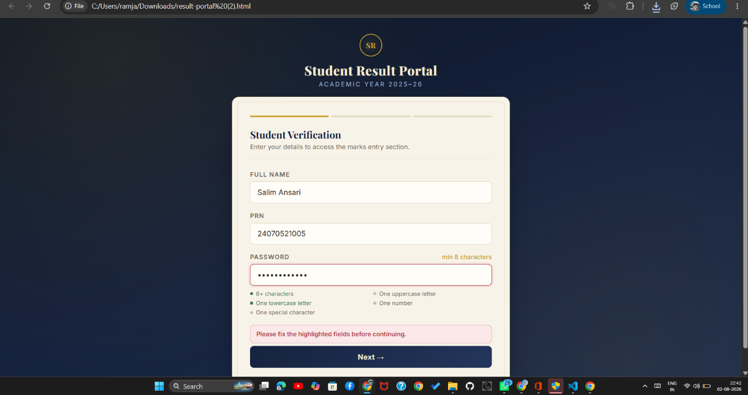
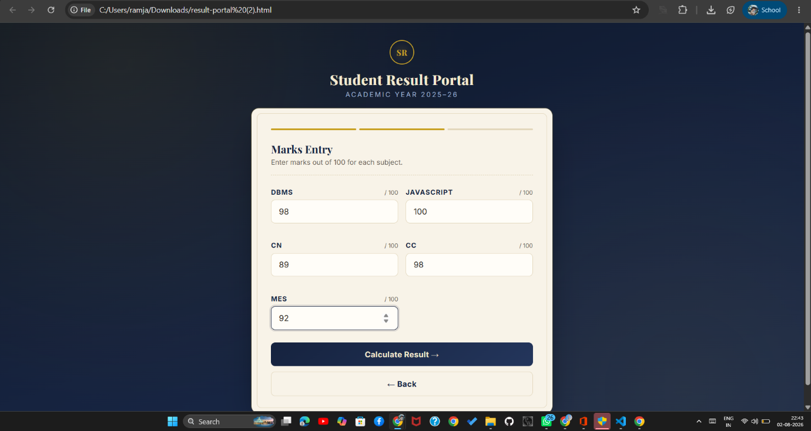
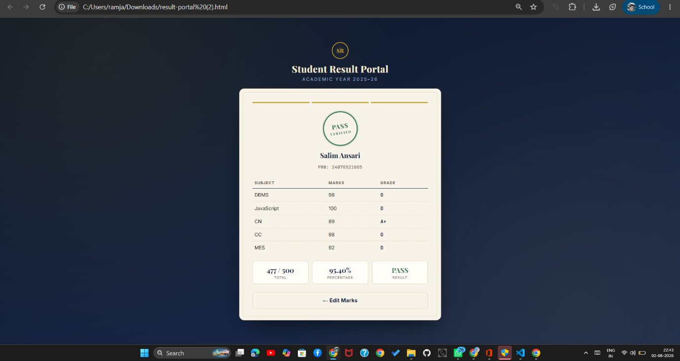

Conclusion –
The experiment was successfully performed to understand JavaScript conditional statements and form validation. A Student Grading System was developed to assign grades on the marks entered by the user. A Login Page was also created to validate user credentials using conditional statements and display appropriate messages for invalid input.

